**22AIE303**

**LABSHEET - 9**

Name : **Anuvind M P**

Roll no. : **AM.EN.U4AIE22010**

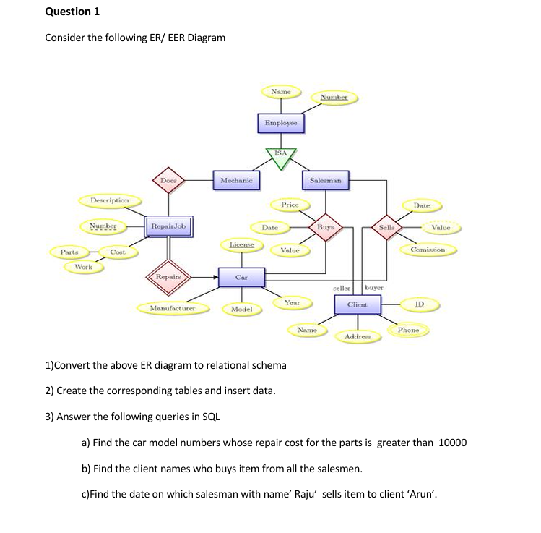

**Schema Diagram**

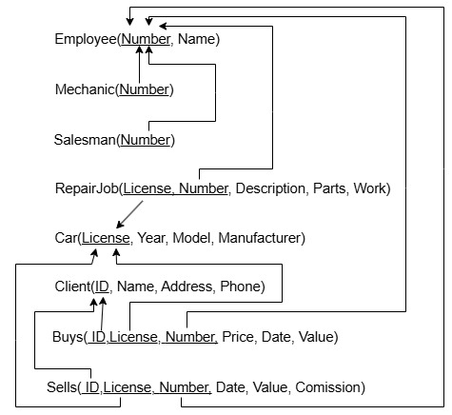

**Code**

*--QUESTION 1--*

*-- CREATE TABLE Employee_lab9 (*

*-- Number INT PRIMARY KEY,*

*-- Name VARCHAR(100)*

*-- );*

*-- CREATE TABLE Mechanic_lab9 (*

*-- Number INT PRIMARY KEY,*

*-- FOREIGN KEY (Number) REFERENCES Employee_lab9(Number)*

*-- );*

*-- CREATE TABLE Salesman_lab9 (*

*-- Number INT PRIMARY KEY,*

*-- FOREIGN KEY (Number) REFERENCES Employee_lab9(Number)*

*-- );*

*-- CREATE TABLE Car_lab9 (*

*-- License VARCHAR(50) PRIMARY KEY,*

*-- Year INT,*

*-- Model VARCHAR(50),*

*-- Manufacturer VARCHAR(50)*

*-- );*

*-- CREATE TABLE RepairJob_lab9 (*

*-- License VARCHAR(50),*

*-- Number INT,*

*-- Description VARCHAR(255),*

*-- Parts INT,*

*-- Work INT,*

*-- PRIMARY KEY (License, Number),*

*-- FOREIGN KEY (License) REFERENCES Car_lab9(License)*

*-- );*

*-- CREATE TABLE Client_lab9 (*

*-- ID INT PRIMARY KEY,*

*-- Name VARCHAR(100),*

*-- Address VARCHAR(255),*

*-- Phone VARCHAR(15)*

*-- );*

*-- CREATE TABLE Buys_lab9 (*

*-- Number INT,*

*-- License VARCHAR(50),*

*-- ID INT,*

*-- Price DECIMAL(10, 2),*

*-- Date DATE,*

*-- Value DECIMAL(10, 2),*

*-- PRIMARY KEY (Number, License, ID),*

*-- FOREIGN KEY (Number) REFERENCES Salesman_lab9(Number),*

*-- FOREIGN KEY (License) REFERENCES Car_lab9(License),*

*-- FOREIGN KEY (ID) REFERENCES Client_lab9(ID)*

*-- );*

*-- CREATE TABLE Sells_lab9 (*

*-- Number INT,*

*-- License VARCHAR(50),*

*-- ID INT,*

*-- Date DATE,*

*-- Value DECIMAL(10, 2),*

*-- Commission DECIMAL(10, 2),*

*-- PRIMARY KEY (Number, License, ID),*

*-- FOREIGN KEY (Number) REFERENCES Salesman_lab9(Number),*

*-- FOREIGN KEY (License) REFERENCES Car_lab9(License),*

*-- FOREIGN KEY (ID) REFERENCES Client_lab9(ID)*

*-- );*

*-- -- Insert data into Employee_lab9*

*-- INSERT INTO Employee_lab9 VALUES (1, 'Raju'), (2, 'John'), (3, 'Mike'), (4, 'Arun');*

*-- -- Insert data into Mechanic_lab9*

*-- INSERT INTO Mechanic_lab9 VALUES (3);*

*-- -- Insert data into Salesman_lab9*

*-- INSERT INTO Salesman_lab9 VALUES (1), (2);*

*-- -- Insert data into Car_lab9*

*-- INSERT INTO Car_lab9 VALUES*

*-- ('A123', 2015, 'ModelX', 'Tesla'),*

*-- ('B456', 2018, 'ModelS', 'Tesla'),*

*-- ('C789', 2020, 'Civic', 'Honda');*

*-- -- Insert data into Client_lab9*

*-- INSERT INTO Client_lab9 VALUES*

*-- (101, 'Arun', 'Street 1', '9876543210'),*

*-- (102, 'Mike', 'Street 2', '9876543211');*

*-- -- Insert data into RepairJob_lab9*

*-- INSERT INTO RepairJob_lab9 VALUES*

*-- ('A123', 1, 'Engine Repair', 15000, 5),*

*-- ('B456', 2, 'Battery Replacement', 8000, 2);*

*-- -- Insert data into Buys_lab9*

*-- INSERT INTO Buys_lab9 VALUES*

*-- (1, 'A123', 101, 25000, '2024-12-01', 23000),*

*-- (2, 'B456', 102, 20000, '2024-12-02', 18000);*

*-- -- Insert data into Sells_lab9*

*-- INSERT INTO Sells_lab9 VALUES*

*-- (1, 'A123', 101, '2024-12-01', 23000, 500),*

*-- (1, 'C789', 102, '2024-12-03', 18000, 400),*

*-- (2, 'B456', 102, '2024-12-04', 19000, 300);*

*--1)*

*-- SELECT Car_lab9.Model*

*-- FROM Car_lab9*

*-- JOIN RepairJob_lab9 ON Car_lab9.License = RepairJob_lab9.License*

*-- WHERE RepairJob_lab9.Parts > 10000;*

*--2)*

*-- SELECT DISTINCT Client_lab9.Name*

*-- FROM Client_lab9*

*-- WHERE NOT EXISTS (*

*-- SELECT Salesman_lab9.Number*

*-- FROM Salesman_lab9*

*-- WHERE NOT EXISTS (*

*-- SELECT 1*

*-- FROM Buys_lab9*

*-- WHERE Buys_lab9.Number = Salesman_lab9.Number AND Buys_lab9.ID = Client_lab9.ID*

*-- )*

*-- );*

*--3)*

*-- SELECT Sells_lab9.Date*

*-- FROM Sells_lab9*

*-- JOIN Employee_lab9 AS Salesman ON Sells_lab9.Number = Salesman.Number*

*-- JOIN Client_lab9 ON Sells_lab9.ID = Client_lab9.ID*

*-- WHERE Salesman.Name = 'Raju' AND Client_lab9.Name = 'Arun';*

**Output**

1.

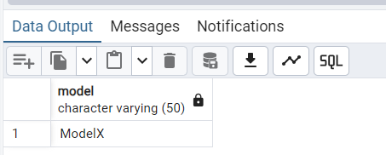

2.

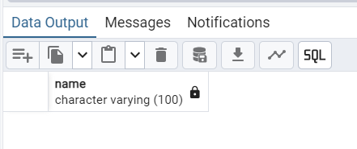

3.

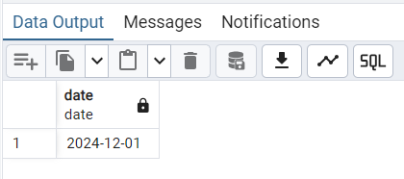

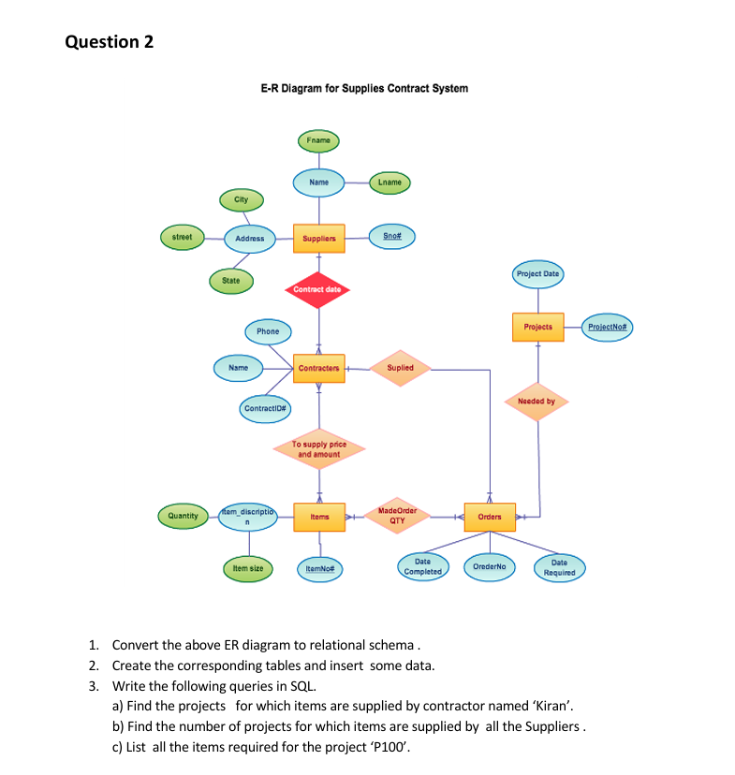

**Schema Diagram**

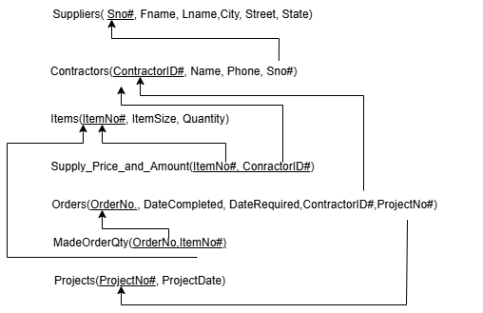

**CODE**

*-- -- Create Suppliers Table*

*-- CREATE TABLE Suppliers_lab9 (*

*-- Sno INT PRIMARY KEY,*

*-- Fname VARCHAR(50),*

*-- Lname VARCHAR(50),*

*-- City VARCHAR(50),*

*-- Street VARCHAR(50),*

*-- State VARCHAR(50)*

*-- );*

*-- -- Create Contractors Table*

*-- CREATE TABLE Contractors_lab9 (*

*-- ContractorID INT PRIMARY KEY,*

*-- Name VARCHAR(50),*

*-- Phone VARCHAR(15),*

*-- Sno INT,*

*-- FOREIGN KEY (Sno) REFERENCES Suppliers_lab9(Sno)*

*-- );*

*-- -- Create Items Table*

*-- CREATE TABLE Items_lab9 (*

*-- ItemNo INT PRIMARY KEY,*

*-- ItemSize VARCHAR(20),*

*-- Quantity INT*

*-- );*

*-- -- Create Supply_Price_and_Amount Table*

*-- CREATE TABLE Supply_Price_and_Amount_lab9 (*

*-- ItemNo INT,*

*-- ContractorID INT,*

*-- PRIMARY KEY (ItemNo, ContractorID),*

*-- FOREIGN KEY (ItemNo) REFERENCES Items_lab9(ItemNo),*

*-- FOREIGN KEY (ContractorID) REFERENCES Contractors_lab9(ContractorID)*

*-- );*

*-- -- Create Projects Table*

*-- CREATE TABLE Projects_lab9 (*

*-- ProjectNo INT PRIMARY KEY,*

*-- ProjectDate DATE*

*-- );*

*-- -- Create Orders Table (with FK for ProjectNo)*

*-- CREATE TABLE Orders_lab9 (*

*-- OrderNo INT PRIMARY KEY,*

*-- DateCompleted DATE,*

*-- DateRequired DATE,*

*-- ContractorID INT,*

*-- ProjectNo INT,*

*-- FOREIGN KEY (ContractorID) REFERENCES Contractors_lab9(ContractorID),*

*-- FOREIGN KEY (ProjectNo) REFERENCES Projects_lab9(ProjectNo)*

*-- );*

*-- -- Create MadeOrderQty Table*

*-- CREATE TABLE MadeOrderQty_lab9 (*

*-- OrderNo INT,*

*-- ItemNo INT,*

*-- PRIMARY KEY (OrderNo, ItemNo),*

*-- FOREIGN KEY (OrderNo) REFERENCES Orders_lab9(OrderNo),*

*-- FOREIGN KEY (ItemNo) REFERENCES Items_lab9(ItemNo)*

*-- );*

*-- INSERT INTO Suppliers_lab9 (Sno, Fname, Lname, City, Street, State) VALUES*

*-- (1, 'Kiran', 'Patel', 'Mumbai', 'MG Road', 'Maharashtra'),*

*-- (2, 'John', 'Doe', 'Delhi', 'Ring Road', 'Delhi'),*

*-- (3, 'Alice', 'Smith', 'Bangalore', 'MG Road', 'Karnataka');*

*-- INSERT INTO Contractors_lab9 (ContractorID, Name, Phone, Sno) VALUES*

*-- (101, 'Kiran Constructions', '1234567890', 1),*

*-- (102, 'BuildTech', '9876543210', 2),*

*-- (103, 'PrimeWorks', '5556667777', 3);*

*-- INSERT INTO Items_lab9 (ItemNo, ItemSize, Quantity) VALUES*

*-- (1, 'Large', 500),*

*-- (2, 'Medium', 300),*

*-- (3, 'Small', 200);*

*-- INSERT INTO Supply_Price_and_Amount_lab9 (ItemNo, ContractorID) VALUES*

*-- (1, 101),*

*-- (2, 101),*

*-- (3, 102),*

*-- (1, 103),*

*-- (2, 103);*

*-- INSERT INTO Projects_lab9 (ProjectNo, ProjectDate) VALUES*

*-- (1001, '2024-11-01'),*

*-- (1002, '2024-11-05'),*

*-- (1003, '2024-11-10');*

*-- INSERT INTO Orders_lab9 (OrderNo, DateCompleted, DateRequired, ContractorID, ProjectNo) VALUES*

*-- (1, '2024-12-01', '2024-12-15', 101, 1001),*

*-- (2, '2024-11-20', '2024-12-05', 102, 1002),*

*-- (3, '2024-11-15', '2024-12-10', 103, 1003);*

*-- INSERT INTO MadeOrderQty_lab9 (OrderNo, ItemNo) VALUES*

*-- (1, 1),*

*-- (1, 2),*

*-- (2, 3),*

*-- (3, 1),*

*-- (3, 2);*

*--QUERY 1*

*-- SELECT DISTINCT Projects_lab9.ProjectNo*

*-- FROM Projects_lab9*

*-- JOIN Orders_lab9 ON Projects_lab9.ProjectNo = Orders_lab9.ProjectNo*

*-- JOIN Contractors_lab9 ON Orders_lab9.ContractorID = Contractors_lab9.ContractorID*

*-- WHERE Contractors_lab9.Name LIKE '%Kiran%';*

*-- -- Insert Suppliers*

*-- INSERT INTO Suppliers_lab9 (Sno, Fname, Lname, City, Street, State) VALUES*

*-- (4, 'David', 'Johnson', 'Pune', 'JM Road', 'Maharashtra'),*

*-- (5, 'Sara', 'Williams', 'Chennai', 'Anna Salai', 'Tamil Nadu');*

*-- -- Insert Contractors*

*-- INSERT INTO Contractors_lab9 (ContractorID, Name, Phone, Sno) VALUES*

*-- (104, 'David Constructions', '9999999999', 4),*

*-- (105, 'Sara Enterprises', '8888888888', 5);*

*-- -- Insert Items*

*-- INSERT INTO Items_lab9 (ItemNo, ItemSize, Quantity) VALUES*

*-- (4, 'Extra Large', 100),*

*-- (5, 'Small', 50);*

*-- -- Insert Supply_Price_and_Amount*

*-- INSERT INTO Supply_Price_and_Amount_lab9 (ItemNo, ContractorID) VALUES*

*-- (1, 104), -- Item 1 supplied by David*

*-- (2, 104), -- Item 2 supplied by David*

*-- (3, 105), -- Item 3 supplied by Sara*

*-- (4, 105), -- Item 4 supplied by Sara*

*-- (5, 104), -- Item 5 supplied by David*

*-- (5, 105); -- Item 5 supplied by Sara*

*-- -- Insert Projects*

*-- INSERT INTO Projects_lab9 (ProjectNo, ProjectDate) VALUES*

*-- (1004, '2024-12-01'),*

*-- (1005, '2024-12-05');*

*-- -- Insert Orders*

*-- INSERT INTO Orders_lab9 (OrderNo, DateCompleted, DateRequired, ContractorID, ProjectNo) VALUES*

*-- (4, '2024-12-03', '2024-12-10', 104, 1004), -- David's order for project 1004*

*-- (5, '2024-12-06', '2024-12-15', 105, 1005); -- Sara's order for project 1005*

*-- -- Insert MadeOrderQty*

*-- INSERT INTO MadeOrderQty_lab9 (OrderNo, ItemNo) VALUES*

*-- (4, 1), -- Order 4 contains Item 1*

*-- (4, 2), -- Order 4 contains Item 2*

*-- (5, 3), -- Order 5 contains Item 3*

*-- (5, 4), -- Order 5 contains Item 4*

*-- (5, 5); -- Order 5 contains Item 5*

*--QUERY 2*

*-- SELECT COUNT(*) AS NumberOfProjects*

*-- FROM (*

*-- SELECT Projects_lab9.ProjectNo*

*-- FROM Projects_lab9*

*-- JOIN Orders_lab9 ON Projects_lab9.ProjectNo = Orders_lab9.ProjectNo*

*-- JOIN MadeOrderQty_lab9 ON Orders_lab9.OrderNo = MadeOrderQty_lab9.OrderNo*

*-- JOIN Supply_Price_and_Amount_lab9 ON MadeOrderQty_lab9.ItemNo = Supply_Price_and_Amount_lab9.ItemNo*

*-- GROUP BY Projects_lab9.ProjectNo*

*-- HAVING COUNT(DISTINCT Supply_Price_and_Amount_lab9.ContractorID) = (SELECT COUNT(*) FROM Suppliers_lab9)*

*-- ) AS AllSuppliersProjects;*

*--QUERY 3*

*-- SELECT DISTINCT Items_lab9.ItemNo, Items_lab9.ItemSize*

*-- FROM Items_lab9*

*-- JOIN MadeOrderQty_lab9 ON Items_lab9.ItemNo = MadeOrderQty_lab9.ItemNo*

*-- JOIN Orders_lab9 ON MadeOrderQty_lab9.OrderNo = Orders_lab9.OrderNo*

*-- WHERE Orders_lab9.ProjectNo = 1001;*

**OUTPUTS**

**1.**

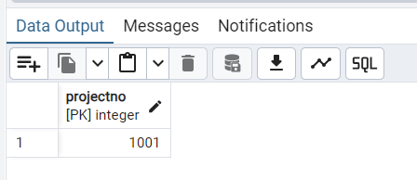

2.

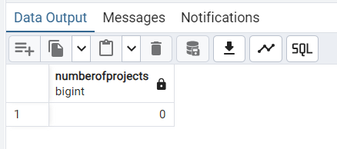

3.

